In our previous aCGH study of DCIS, we have identified four genomic regions associated with invasion in breast cancer with 17q22-23 being one of the regions. In this study, we identified four genes in this region that can potentially be related to breast cancer progression: COIL, WIPI1, TMEM100, and SLC16A6. We examined the mRNA expression of these genes across a panel of breast cancer cell lines and the normal mammary cell line MCF-10A (A – D), and only COIL and WIPI1 were found to be expressed across all 8 breast cancer cell lines. Then, we examined the protein expression of COIL and WIPI1 and confirmed that these genes were expressed in a majority of the breast cancer cell lines (E). Further experiments will be required to determine the role of these genes in the progression of breast cancer.

RAD51 family proteins have been associated with high risk breast cancer without BRCA1/2 mutations. Within the region of 17q22-23, there is a protein belonging to the RAD51 family, RAD51C. RAD51C is known to encode strand-transfer proteins and thought to be involved in recombinational repair of DNA damage. Given its genomic location and function, we predicted that this gene could be involved in breast cancer progression. First, we confirmed that RAD51C was expressed at the protein level across a panel of breast cancer cell lines (A). Then, we overexpressed RAD51C in the MCF-7 breast cancer cell line (B), and found that RAD51C overexpression reduced proliferation (as measured by absorbance at 490nm; C), migration (D) and invasion (E) resulting in a reduced invasion index (F) compared to wild-type and GFP-expressing controls. This suggests that if RAD51C is amplified and overexpressed, it might serve a protective role in breast cancer progression.

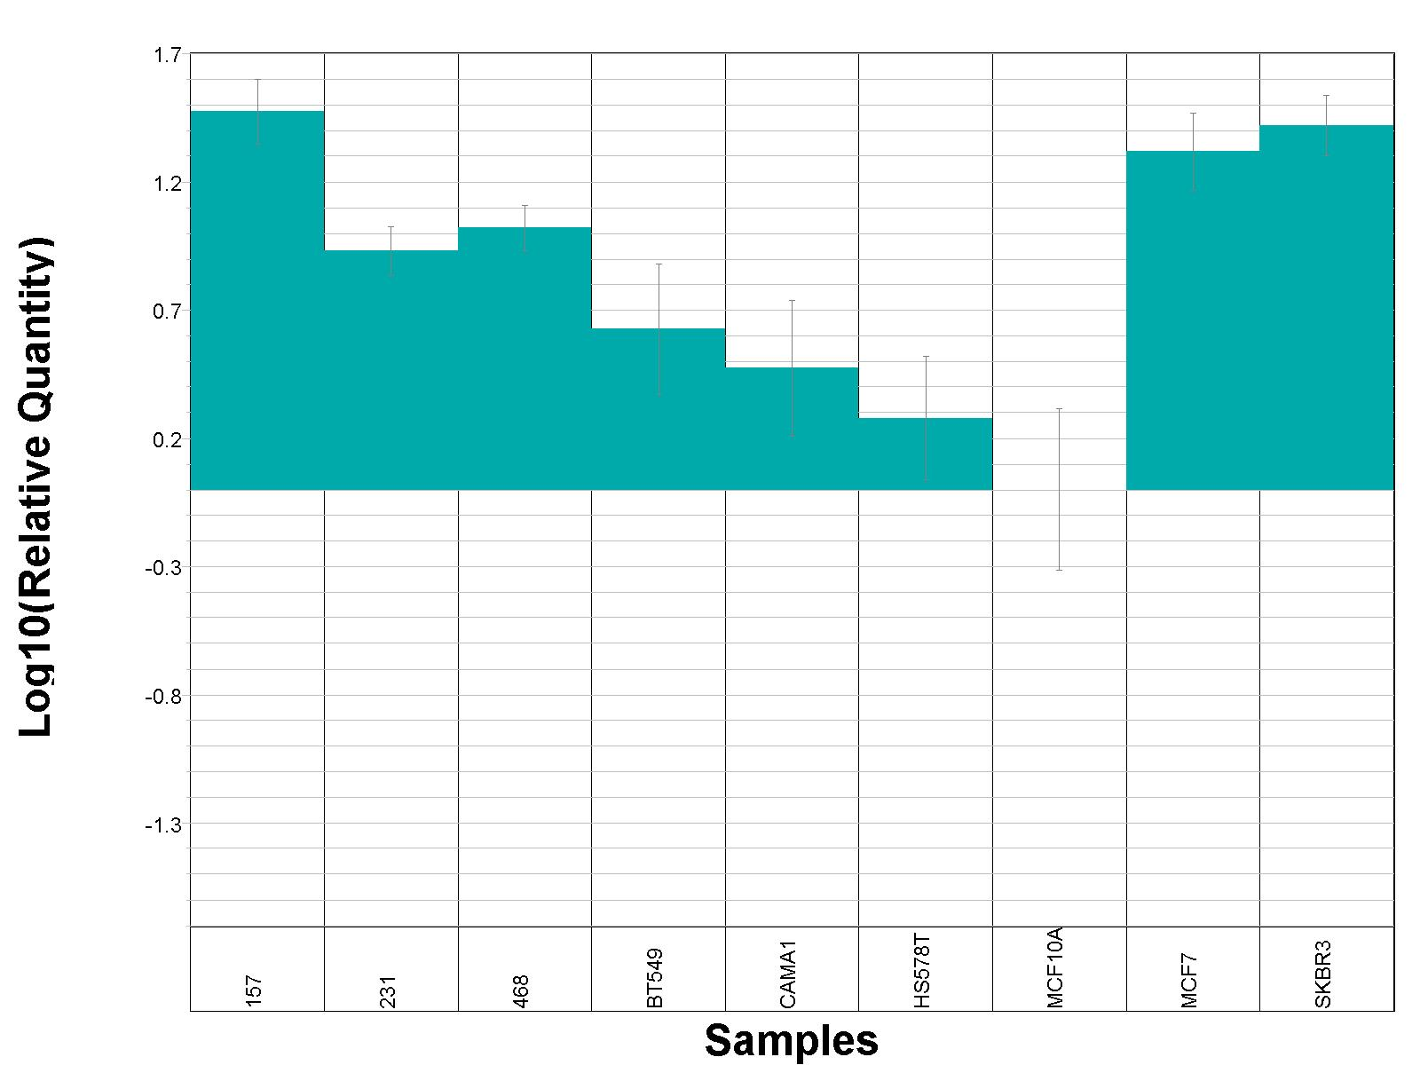
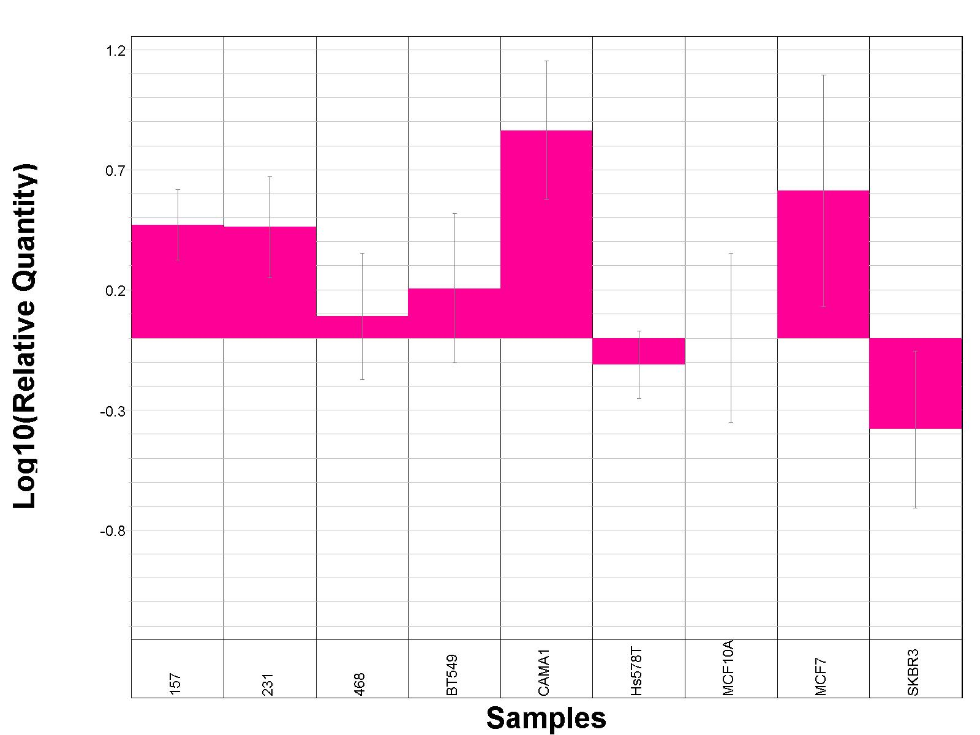
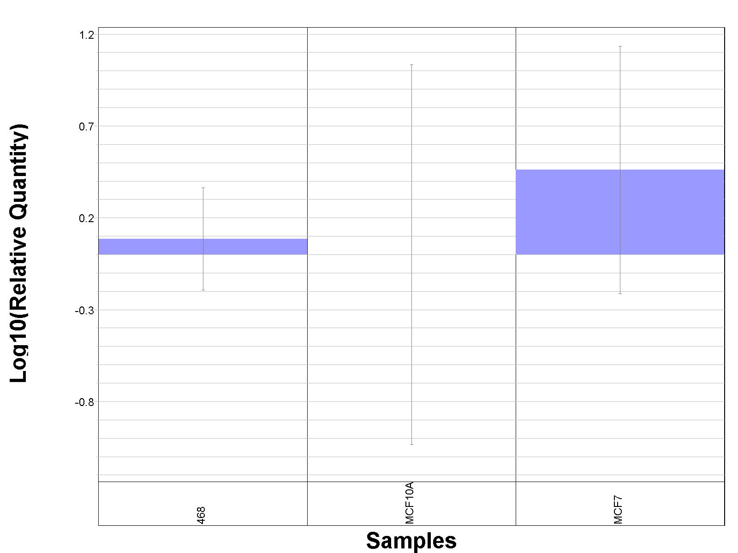
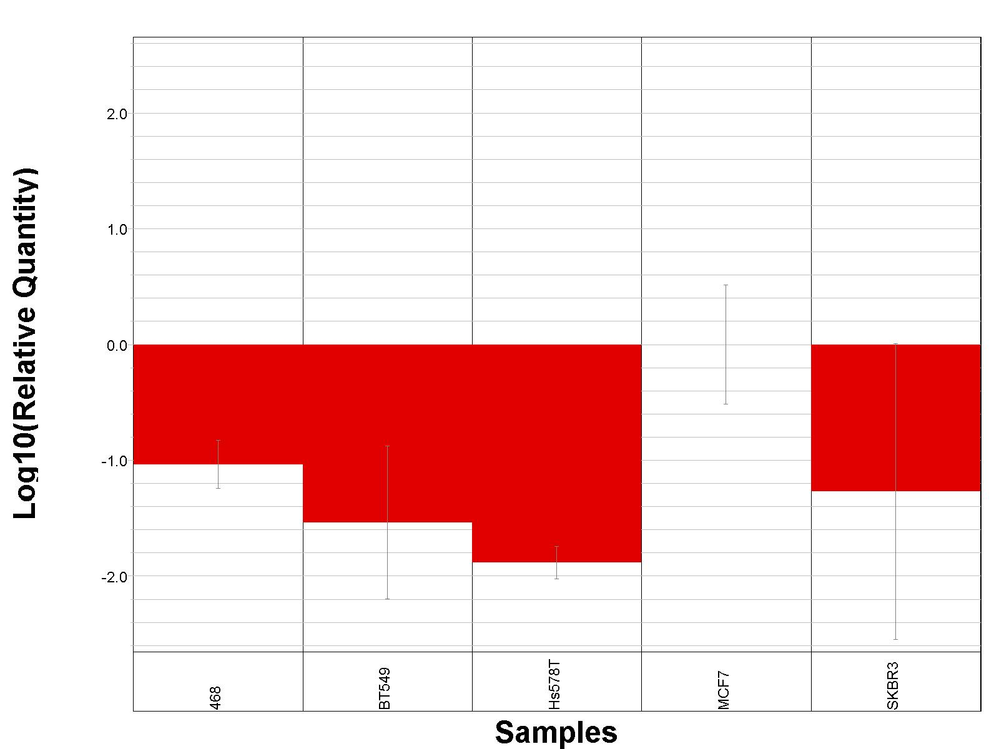
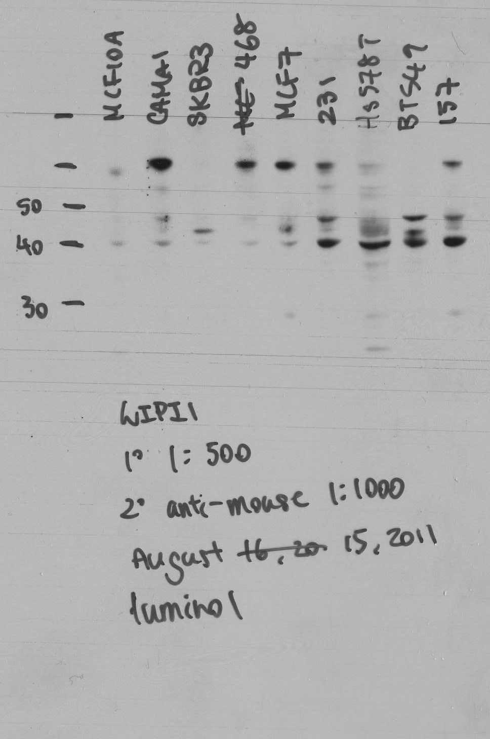
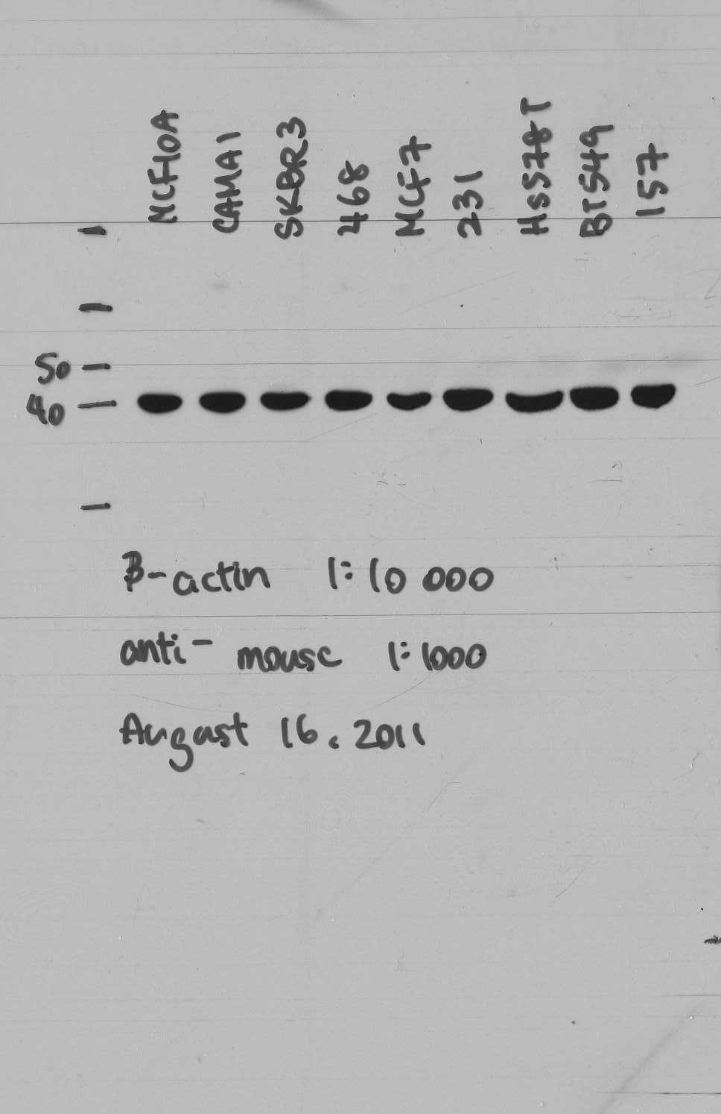
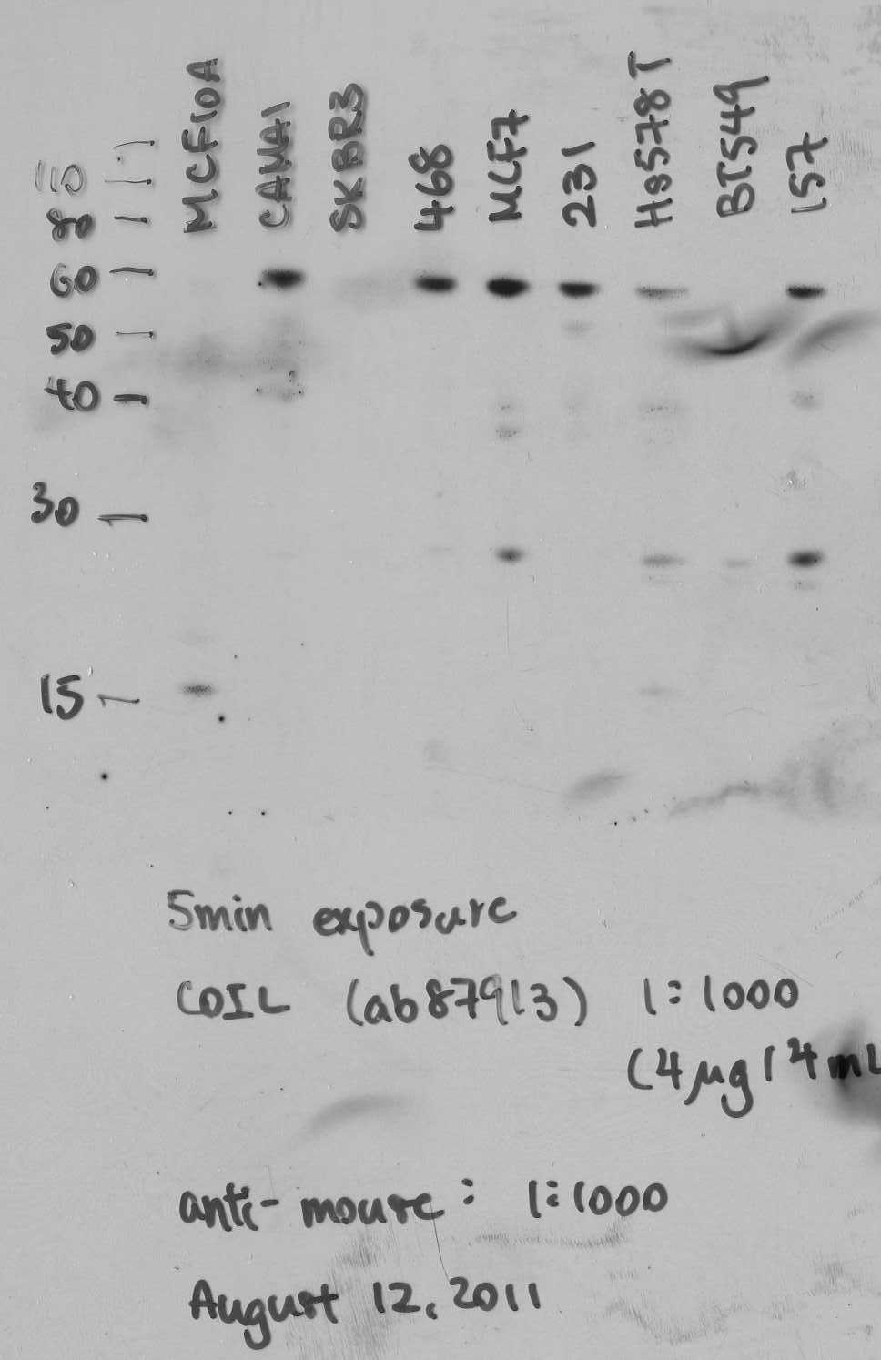
mRNA expression of (A)COIL, (B)WIPI1, (C)TMEM100, and (D)SLC16A6 in human breast cancer cell lines as measured using quantitative real-time PCR with 40ng cDNA relative to GAPDH. (A – C) were expressed relative to MCF-10A ± SD, and (D) was expressed relative to MCF-7 ± SD. (E) Protein expression of COIL and WIPI1 were confirmed in human breast cancer cell lines with 10μg of proteins/lane.
MDA-MB-157
MDA-MB-231
MDA-MB-468
BT-549
CAMA-1
Hs578T
MCF-10A
MCF-7
SKBR-3
Log₁₀ (Relative Quantity)
B
A
MDA-MB-157
MDA-MB-231
MDA-MB-468
BT-549
CAMA-1
Hs578T
MCF-10A
MCF-7
SKBR-3
Log₁₀ (Relative Quantity)
MDA-MB-468
MCF-10A
MCF-7
Log₁₀ (Relative Quantity)
C
Log₁₀ (Relative Quantity)
MDA-MB-468
BT-549
Hs578T
MCF-7
SKBR-3
D
β-actin
MCF-10A
CAMA-1
SKBR-3
MDA-MB-468
MCF-7
MDA-MB-231
Hs578T
BT-549
MDA-MB-157
WIPI1
COIL
E

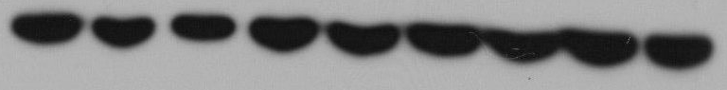
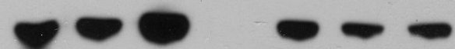
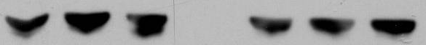
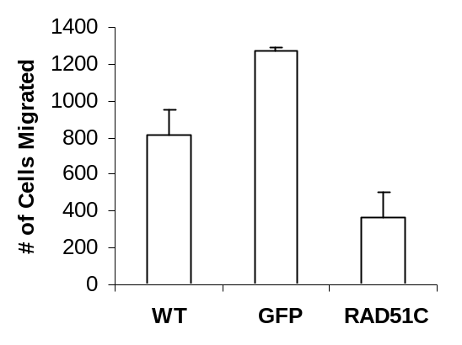
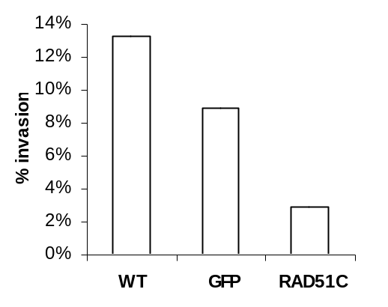
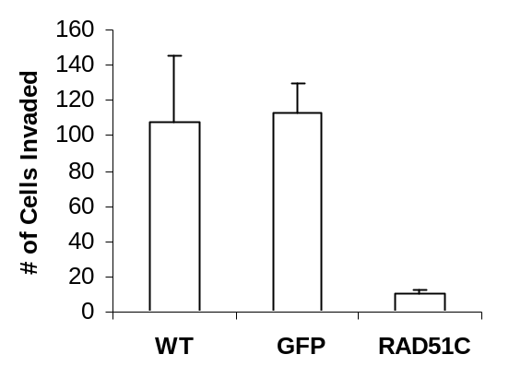
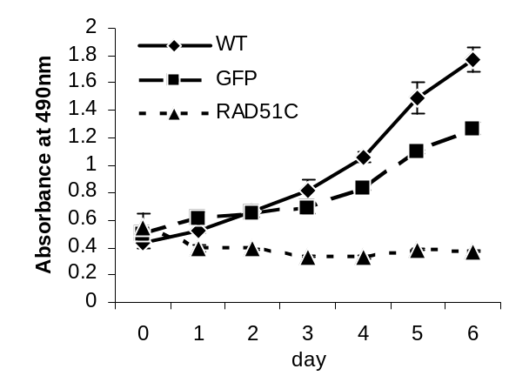
(A)RAD51C is expressed at different levels across breast cancer cell lines. (B)RAD51C-expressing clones showed an increased expression of RAD51C compared to wild-type (WT) and green-fluorescent protein (GFP)-expressing clones. (C) RAD51C overexpression in the MCF-7 cell line decreased absorbance at 490nm after incubation of MTS reagent, indicating a reduction in proliferation compared to WT and GFP-expressing clones. (D-F) RAD51C overexpression decreased the migration (D) and invasion (E) in TranswellTM invasion chambers, resulting in a reduced invasion index (F) compared to WT and GFP-expressing clones. (C – E) Data are expressed as mean values of at least 3 replicates ± SD.
RAD51C
β-actin
MCF-10A
CAMA-1
SKBR-3
MDA-MB-468
MCF-7
MDA-MB-231
Hs578T
BT-549
MDA-MB-157
RAD51C
β-actin
GFP
RAD51C
WT
A
B
C
D
E
F

